# Job Application Tracking System

INTRODUCTION

1.1 Overview

Project aim is to provide real-time knowledge for all the students who have basic knowledge of Salesforce and Looking for a real-time project. This project will also help to those professionals who are in cross-technology and wanted to switch to Salesforce with the help of this project they will gain knowledge and can include into their resume as well.

1.2 Purpose

Many employers have all applicants fill out the same job application, regardless of experience level or previous company connections. This can help to create a structured application process,often beginning with an application form and proceeding through several rounds of interviews. Here are a few other common job application purposes:

# Problem Definition and Design Thinking

## 2.1 Empathy Map C:\Users\admin\Downloads\IMG_20230413_135508.jpg

## 2.2 Ideation and Brainstorming Map

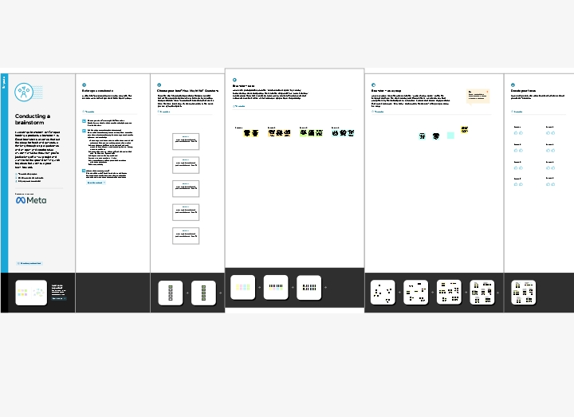

## Result

## 3.1 Data model:

|  |  |  |
| --- | --- | --- |
| Column Heading | Description | What to Enter? |
| Source name type | * Import from Candidate Resume * Entries by candidates when they apply for the job. | Select an option from the dropdown list. |
| Label | In the upper right corner of only valid when the source name type is candidate input. | Maintain the field label in English and Chinese. |
| Source name | Import from Candidate profile. | Enter the field name in the candidate profile. |
| Required | Defines whether this field being mapped is a mandatory field in the target system. | Select the Required check box if the field is mandatory in the target system. |
| Country/Region specific | If the field being mapped is country/region specific, you need to specify for which country or region the field is applicable. | Select the country or region for which the field is applicable. |
| Default value | Default value of this field | If the field is a picklist, the default value must be a picklist option lable. |

## 3.1 Activity and Screen short

## Milestone1- Salesforce:

## Activity-1:

Creating Developer Account creating a developer org in salesfor

1.Go to developers.salseforce.com/

2.Click on sign up.

3.On the sign-up form, enter the following details:

* First name and last name
* Email
* Role: Administer
* Company: College Name
* County: India
* Postal Code: Pin code
* Username: Should be a combination of your name and company this need not be an actual email id, you can give anything in the format: username@organization.com

Click on sign up after filling these.

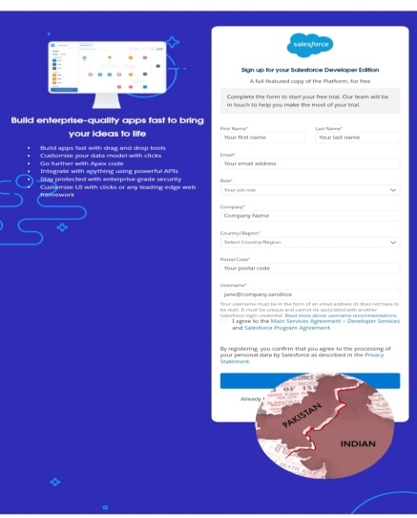

* Click sign me up, after a few min you will reserve a mail sales force org and by using the verify account link you can create new password.
* Click save.
* Search login. Salseforce.com
* By using username and password you can into the salesforce org.

The set up page will appear as below

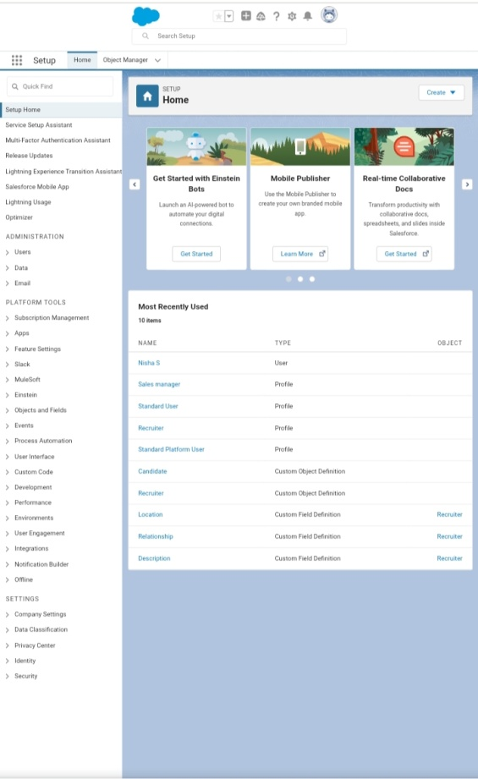

## Milestone 2- Object

### Create a custom object for Recruiter:

To create a custom object, follow these steps.

* From setup click on object manager.
* Click create, select custom object.
* Fill in the label as Recruiter
* Fill in the plural lable as Recruiter Number
* Record name: Recruiter Number
* Select the data type as Auto as Auto Number.
* Under display format enter REC-{0000}.
* Enter starting number as 1.
* In the Optional Features section, select Allow Reports and Track Field History.
* In the Deployment status section, ensure Deployed is selected.
* In the search status section, select Allow search.
* In the Object creation options section, select add notes and attachments related list to default page layout.

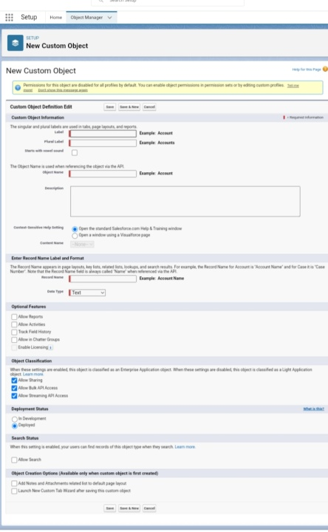

* Leave everything else as is, and click save.

## Activity2:

1.Create a job, Candidate, Job Application Object and Tab.

Note: Follow the steps from the above activity.

## Milestone 3-Fields:

## Activity 1:

### Create the custom fields:

1.Click the object manager tab, select the object for which you have to create the fields and relationships.

2.From the sidebar, click fields and relationships. Notice that there are already some fields there. Those are the standard fields.

3.Click new to create a custom field. Tip: Before creating a new field, do a quick search to make sure similar one does not already exist.

4.Click on the new to create a field.

5.Choose the data type as a Text, click next.

6.Enter field lable, length and name and click next.

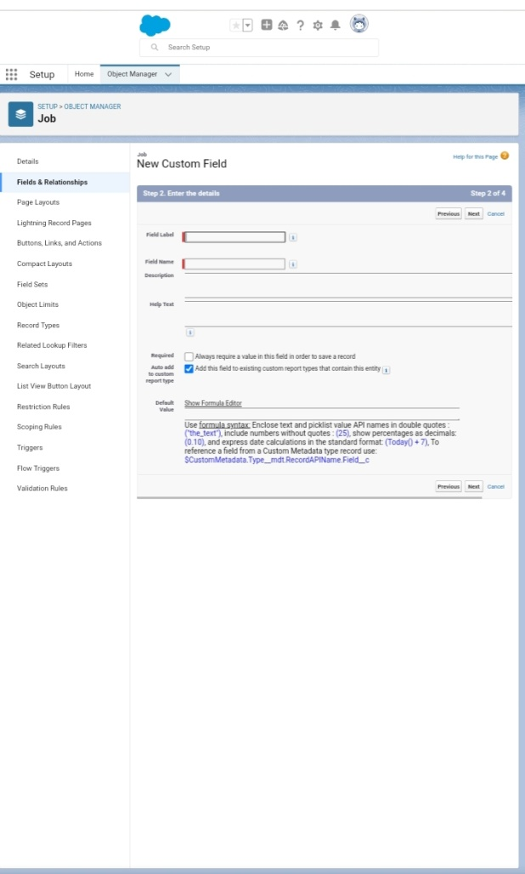

7. Select the profile to which you want grant edit access to this field via field-level security. The field will be hidden from all profiles if you do not add it to field-level security. Click next.

8. Select the page layouts that should include this field.

9. Click save.

# Milestone 4- Tab:

## Create a tab:

1. Click setup
2. Search tab in quick box then, select tab
3. Click new custom object tan section
4. Select the created object Recruiter and tab style for the new custom tab.
5. Select the profiles that visible in the tab
6. Click on custom apps to make visible.
7. Click save.

## Milestone 5- Profile

### Activity1:

### Create a custom profile:

1.From setup, enter profiles in quick find box.

2.Select profiles.

3.Click clone.

4.For Profile, enter Recruiter.

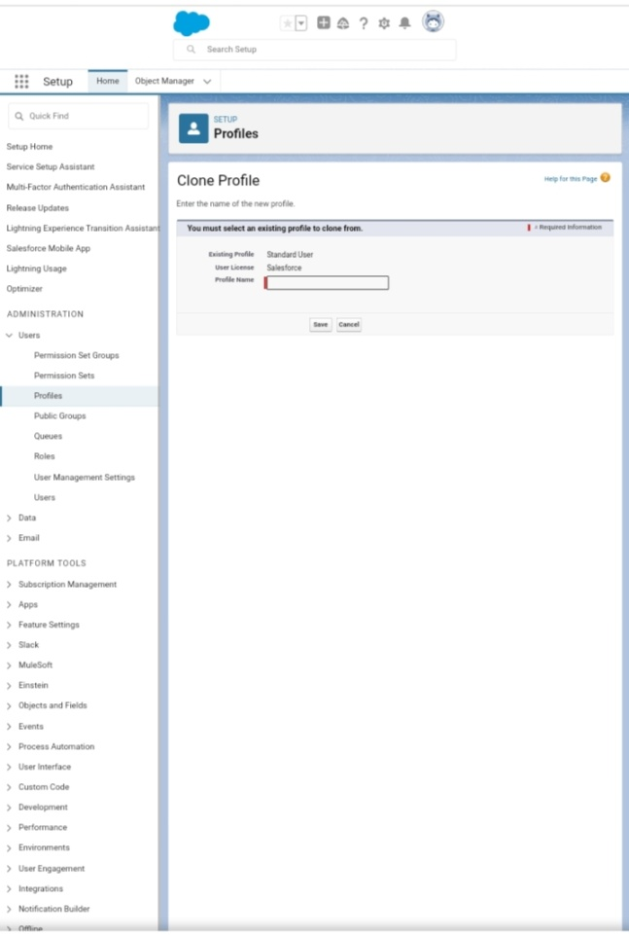

5.Click save.

## Activity2:

Create a profile with the profile name as Sales Manager.

Follow the steps from above activity

## Milestone6- User

## Activity1:

### To create a usert

1.From setup, enter User in the quick find box, then select Users.

2.Click new User.

3.Enter first name as Hr and last name as manager.

4.Enter the user name and email address and a unique username in the form of an email address. By default, the username is the same as the email address.

5.Then create a new role Hr Manager.

6.Select user License as standard platform user.

7. Select profile.

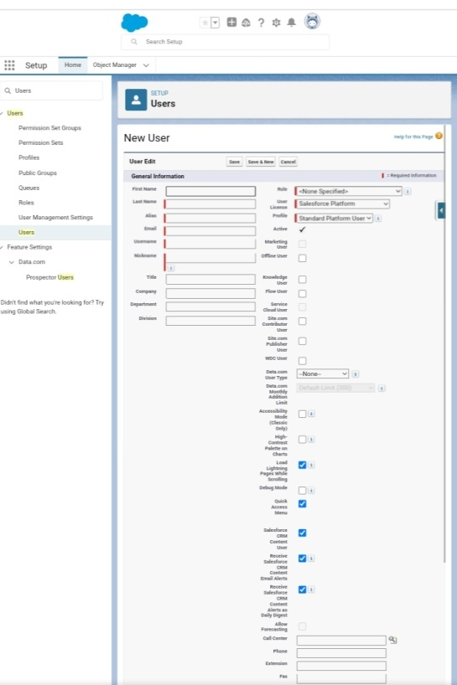

8.Click save

## Milestone7- Sharing Rules

### Create a sharing rule

1.Go to sharing setting, which can be found under the quick find section.

2.Scroll down and find the candidate object where a sharing rule needs to be added, and then click on new to create a new sharing rule.

3.Add the label of the sharing rule you want to make.

4.Select your rule type based on the criteria.

5.Select the field can join immediately check field from the candidate object.

6.Select the operator as equal and value is true.

7.And in selecting the users to share with the section select roles and in that select Hr Manager.

8.And in the section of section of select the level of access for the users give the access Read/Write.

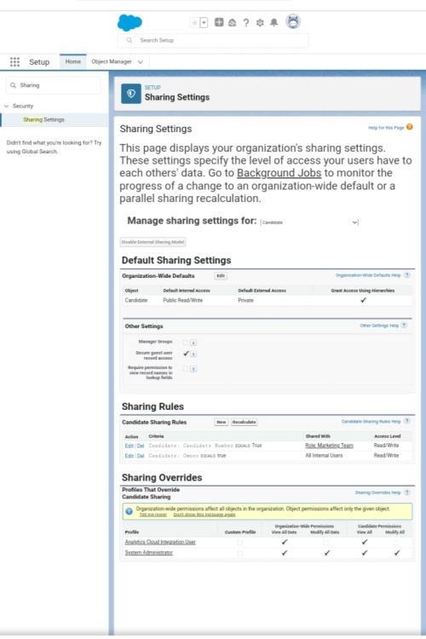

9.And save the rule.

## Milestone8- Reports:

## Activity1:

### Create a Report:

1.Click on app launcher search for reports.

2.Click on the new report and select the category has accounts and contacts.

3.And the report type has accounts.

4.In the details section select the option start report.

5.In the filter select all accounts to show me.

6.And all time is created.

7.In the outline pane, group rows select Rating and in group columns select Account name.

8.In the columns section add Type and Billing city.

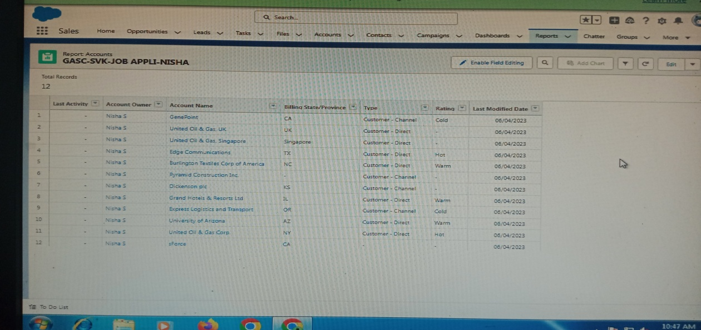

9.Save the report by giving label name and save the folder as a public folder and save the report.

## Trailhead profile public URL

Team Lead- <https://trailblazer.me/id/nishs39>

Team Member1- <https://trailblazer.me/id/devis68>

Team Member2- <https://trailblazer.me/id/dhivp8>

Team Member3- <https://trailblazer.me/id/saraa106>

## Advantages

Using applicant tracking software seems like a great way of saving time when recruiting.

* Reduces time spent on admin tasks.
* Resume and CV screening.
* Speeds up the recruitment cycle.
* Improves the quality of hire.
* Enhances reporting and compliance.
* Boosts your brand.
* Improves on boarding.

## Disadvantages

* Could filter out good candidates.
* Communications can be less personalized.
* Only focuses on data/Analytical information.

## Applications

* Flexible system for both employer and the agency
* Better overview of applications
* Easy job posting
* Improved quality of hire
* Make job posting easier and faster
* Auto- generate reports and helps you track recruiting KPls

## Conclusion

This is a very effective hiring solution that most of the successful recruiters utilize.